My Star

Project

By Megan Henery
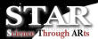

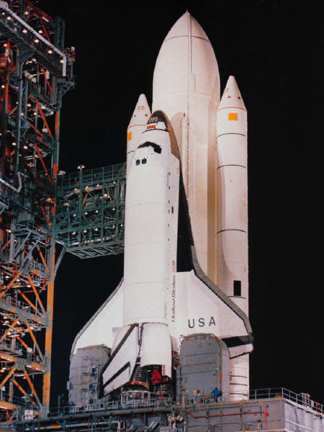

1. About the NASA STAR project

2. What did we do with STAR?

3. Who has helped us with this project?

4. What we have learnt to do?

5. What skills have we used?

6. Our link with NASA

7. What other things have we done?

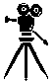

The STAR project is short for Science Through ARts. The STAR project is about using lots of different information and skills, and putting them all together. This enables us to create a piece of writing that includes many different subjects, especially space science.

Our project was to create a film script about a journey to the moon, working in groups of about four, and then being able to act the script out. With the help of NASA (see section six for more details) we succeeded in making scripts that were as realistic as possible. We also did freeze-frames to go with the script, so that they could be put onto the internet.

Our scripts had to be completely correct scientifically, and if we had any queries or questions that we could not find on the Internet, we could ask Joe Kolecki, NASA Mars Pathfinder scientist, who works for NASA in Ohio, and who would answer us by email, and by video-conference. Any pieces of the script that were not correct could be cut out, or changed. All of our scripts were full of facts, and everybody worked very hard.

We also had help from Mr Crowe, our Media Studies teacher, who came into our class to talk to us about different ways to film a piece of drama. We learnt that you can have shots from afar, and close shots. You also can pan the camera so that the camera is moving across the space. You could also have the camera on a track, so that the camera is moving along smoothly with the person.
What do we do with STAR?

With STAR, we learn about space science. We learn about the solar system and how it works. There is also support from the Mirandanet website. With STAR, we work on collaborative projects, and are given help and advice on different aspects of the work. This helps us to improve our scientific knowledge, and to develop our creative writing work.

- NASA scientists
- MirandaNet
- STAR web site
- Joe Kolecki
- Mr. Williams
- Internet

The above people and websites have helped us.

NASA – NASA has helped us a great deal, because a lot of the scientific information in our film scripts came from NASA research, and we had help from their many websites.
Mirandanet - Mirandanet is a website that has helped us by giving us information about different things we needed for our scripts. It supports the ideas behind STAR so that we know what we are doing!
STAR web site- STAR is a website made by NASA and used by us. It answers a lot of our questions, and helps us to understand the science ideas.
Joe Kolecki- Joe helped us with our work, and answered some of our questions by email and by videoconference. He was a great help, and everybody appreciated his work for us. It was nice for us to see Katie showing us Joe’s replies to our emails on the interactive whiteboard.
Mr. Williams- Mr. Williams answered as many questions as possible, and has helped us with our scripts. He helped us to make them as realistic as possible.
The Internet- We all needed to use the internet for research, and it was needed greatly.

What have we learnt to do?

We have learnt how to access e-mail, send attachments, and use different websites. We have also developed our computer skills in many other ways. We have learnt to do PowerPoint presentations and access different websites. We have learned about how to act out different kinds of scripts. It also gave me the chance to learn how to use a digital camera. Most of these things were new to us, and it makes us look at English and science in a completely new way.
What skills have we used?

Skills:

- Computer skills: PowerPoint, Microsoft Word, internet access, email, sending attachments, making digital photos, using the interactive whiteboard, and finding information on the Internet.
- Writing skills: We have improved our word-processing and planning skills by using information given to us by Joe, and developing the information in our scripts. We shared our ideas with each other, like scientists do in real life, and developed our film scripts by emailing sections to each other for discussion in class.
- Drama skills: We have improved our drama skills by learning different ways to show our emotion and feelings, by acting our scenes, and by using freeze-framing techniques to catch the best moment in a scene.
- Filming skills: We all have learnt new skills in filming because we were taught to take different shots e.g. close shots, far shots, panning shots. Some of us used a movie camera for filming the final scenes, as well as a still digital camera for the freeze-frames.

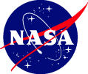

NASA has helped us enormously, by giving us information though the STAR web site, by emailing advice and help, and by checking out our science by email and by video-conference.

NASA has been working with Holy Cross for several years, after Ruth Petersen and Joe Kolecki learned of the cross-curricular work of the school. This helped the project to develop. Because of the help from NASA we would be able to cram many science facts into any work, and have our work checked out by top scientists, as well as having our work put on the Internet!
What other things have we done?

Video-conferences – We had a video conference with Ikeda High School students in Japan, who are also pioneers in working on STAR! It was good fun. The choir performed a few songs and some of the girls performed a piece of drama. It was around Christmas, so we were singing carols, and the skit that was performed was about elves making toys for Christmas. We are using some of their music on our school web site, to support STAR. This really is an international project!

We also showed our freeze-frames live to Joe, in Ohio, and he commented on the science we had included in them. There are some pictures of my class doing their freeze-frames on the STAR web site.


Emails – We sent emails to Joe at NASA, and we were thrilled to have such quick relies to our questions.

Visitors – We had many visitors who came into our class to watch us work on STAR, and to learn new things. Some of the visitors were teachers from South Africa. Mr. Williams visited their school in Free State last summer, and they came to Holy Cross in January, and we demonstrated how to e-mail to each other, and how to use the Internet for working on STAR.

I have really enjoyed working on my STAR film script. It’s a new way of learning science, and developing computer skills, as well as improving my writing and drama skills - all at the same time!

Megan Henery
Year 7 student
The Holy Cross School
Surrey
United Kingdom

