Scene 2

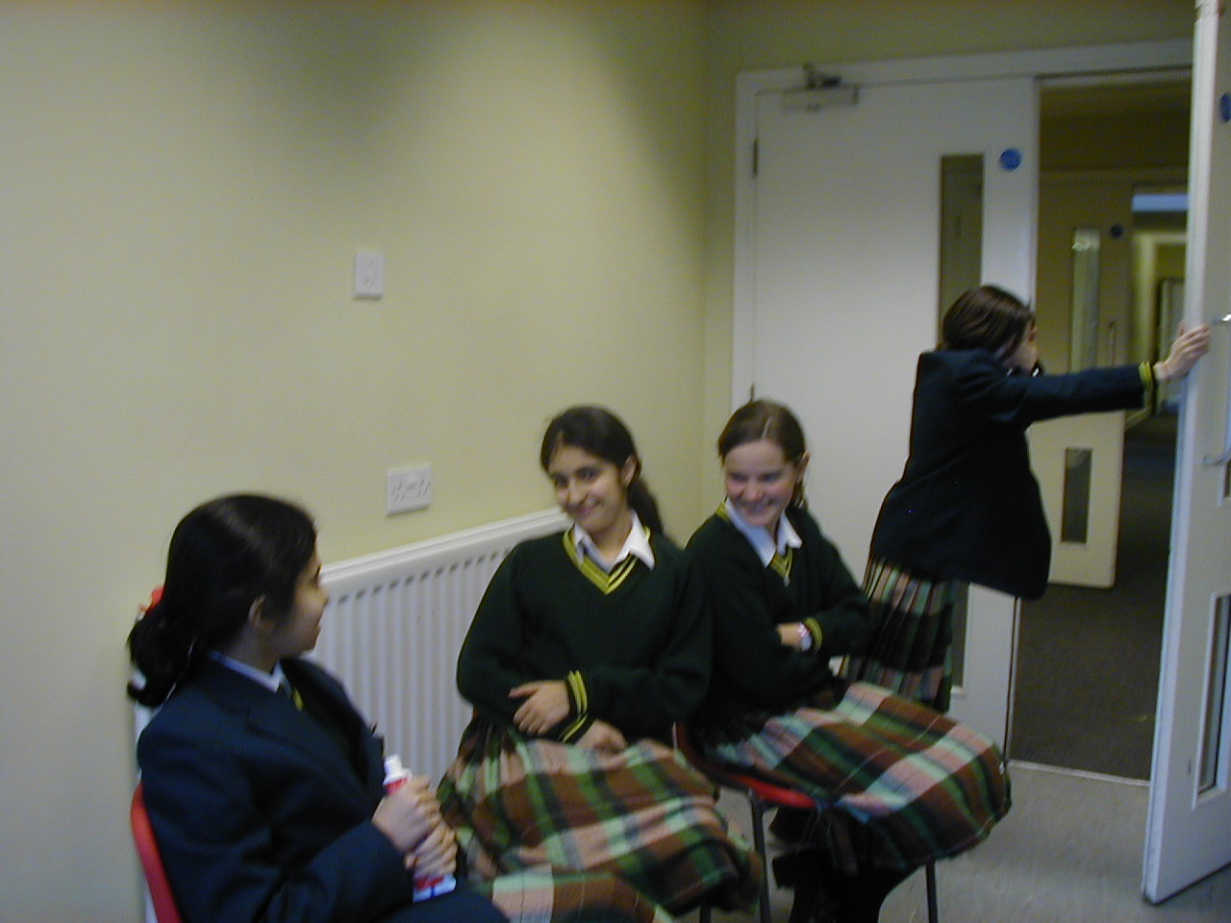
Interview scene, part 2

Presenter: That was very unfortunate, but we are quite used to having people cry on this show! Next on the show we have Alex’s sisters!

(Music plays while the sisters come on stage.)

Presenter: Hi girls, and welcome to the show. Right then, let’s get started with your names.

Brooke: She’s Tanya… Freeze frame of the scene

Tanya: And she’s Brooke.

Presenter: So, tell me, what is it like having your sister up in space, right now?

Tanya: Well, I guess it’s hard being triplets….

Brooke: With only two of us.

Presenter: So, what will it be like celebrating her birthday when she’s not going to be at home?

Brooke: We’ve never actually thought about that. But it will be really weird singing ‘Happy Birthday’ and then only two of us blowing out the candle.

Presenter: Well, she will be missing a few birthdays, because the crew are going on to Mars as well, aren’t they, using the moon as their training ground?

Tanya: Yes, they are, and she will miss a couple of birthdays, because it takes nine months to get up to Mars, and they’ll be spending some time on it, and then getting back home will take another nine months…

Brooke: But we’ll make it up to her when she comes back home.

Presenter: Have you heard about Einstein’s Theory which is if you travel around at the speed of light, you will actually not get older, and will end up younger than the people back on Earth, when you return?

Tanya: Yes, that’s right. When Einstein first had the idea, a lot of scientists thought it was a load of rubbish.

Brooke: Honestly, some people! You just don’t know who to believe.

Presenter: Do you know how they found out this was true?

Tanya: They put a highly accurate clock on an aircraft…

Brooke: …and another one on the ground…

Tanya: …and they measured the time while the aircraft went around the Earth a few times…

Brooke: …and to their surprise they found out that the clock on the aircraft was slower than the one on the ground--by only millionths of a second, of course.

Tanya: Alex made it really clear to us that it had to be a highly accurate clock; otherwise you wouldn’t have seen the difference.

Presenter: Cool! I am definitely asking for one of those next Christmas!

Brooke: I think it might be a bit expensive though!

Presenter: Yeah! And I have just recently heard that anything that is sent up into space would have to be considered carefully, to see if it is worth taking up into space, by the weight of it, and not the quality. I mean, I know it sounds weird, but at the same time it does make sense. So is this actually true?

Tanya: Well, as you probably know, anything that gets sent up into space needs a lot of fuel and energy to get up there.

Presenter: Yes…

Brooke: A lot of fuel means a lot of money, so you’ve got to feel sorry for the people up in space, as they would probably love to take their favourite thick books with them…

Tanya: And that would weigh about a pound…

Brooke: and every pound of material costs around $14,000 - $21,000…

Tanya: … which is a lot of money for a good read!

Brooke: (Getting a bit frustrated with Tanya interrupting her.) …Anyway, as I was saying, you would have to choose what you were going to bring with you very carefully, and if it was necessary. Otherwise it would cost NASA a lot of money!!

Presenter: I’m not going to go up to space that often, then! One more thing, how do you know this much about science and space since you have decided not to study it at school?

Tanya: Well we obviously get all the facts from our free-of-charge tutor, our sister Alex!

Brooke: Yeah! Alex is a really well-educated person, and I would recommend her to anyone as a tutor, but I’m never going to give up my sister!

Presenter: Ah! How sweet of you! (Now talking to the audience.) Give it up for Alex’s mum and sisters! (The audience starts clapping and Alex’s mum comes back on stage.)
Well I’m afraid that’s all we have time for today, but I’ll see you at the same time next week live on Channel 30 with another Special Mum! Bye for now!
(Music starts playing again, and credits roll.)

