Notes on the JPEGs from the film script, as shown to NASA scientist Joe Kolecki
by videoconference, March 2005.

Katie writes:
“Our film script is about six astronauts who, on a second journey, re-discover a footprint on the moon. They believe the footprint could be Neil Armstrong’s or Buzz Aldrin’s. Our freeze-frame below shows this moment:
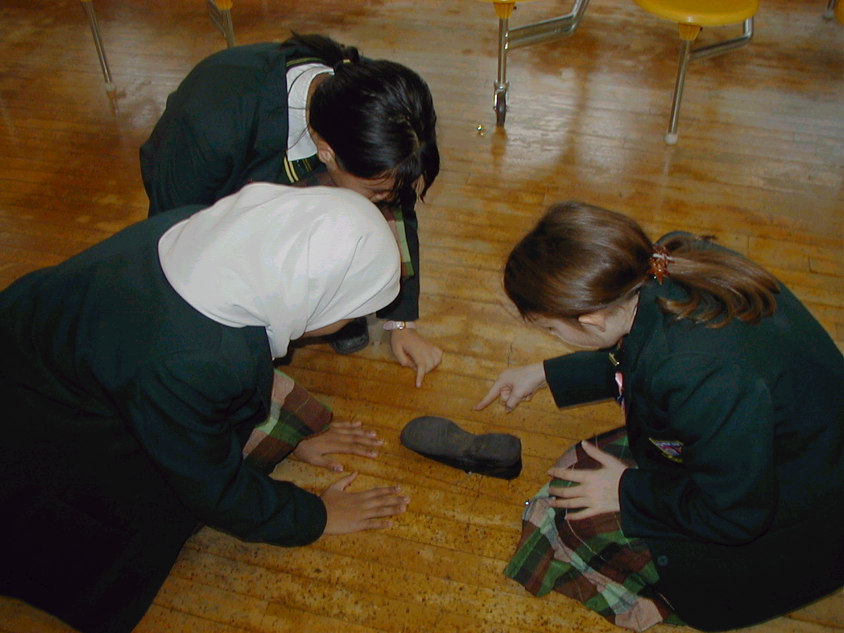

On their way back to Earth, in our film script, a tiny meteorite goes straight through the wall of the spaceship, so the astronauts patch it up with square gel patches. We have since learned, in an email from Joe, that there is a gel within the actual layers of the ship’s hull, which patches these problems up, automatically.

The 'What if' question in our film script was, “What if a tiny meteorite went straight through a spaceship’s hull?”
In this picture, the science is that we know Neil Armstrong and Buzz Aldin were the first people to land on the moon, and left footprints there. We also know that the moon has much less gravity than Earth, and that there is no atmosphere: so there can't be any wind or rain, to blow or wash the footprint away. So, Neil's and Buzz's footprints are most definitely still visible on the moon today.”
Katie 7M Holy Cross

PS Joe Kolecki has since added the following notes on gel:
I like the page that you sent. Please note that the idea of gel between the walls of the spacecraft dates back to the time of von Braun. Other ideas have certainly arisen since.
The use of gel is not the only way to remedy the problem of meteoroid impact. Perhaps the girls can note the provisionality of this idea. Also, gel patches are non-entities. The material between the walls is (was) a thin layer of...stuff (call it "guck," I do not know its technical name) that would melt from the heat of impact, flow across and seal the hole, then re-congeal.

